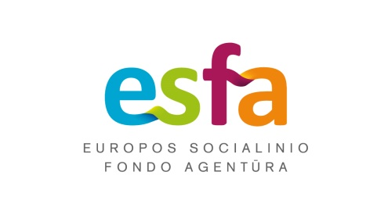



REGISTRATION FORM
Qualification Development Courses for University Teachers,
Vilnius
20th–24th of January 2020

Name, surname
(as it is written in the original document)
Date of birth
Contact information
(address, email, telephone/fax)

Name of the centre

Thank you for filling in the form. Welcome to the courses.

Travelling, accommodation costs in Vilnius and Druskininkai, and all programmes in Druskininkai are covered from the project “Lithuanian Academic Scheme for International Cooperation in Baltic Studies” (No. 09.3.1-ESFA- V-709- 01-0002).


